Project Design Phase Solution Architecture

Date | 11 February 2026
Team ID | LTVIP2026TMIDS88090
Project Name | AUTOSAGE APP USING GEMINI FLASH
Maximum Marks | 4 Marks

Solution Architecture:
Solution architecture for AUTOSAGE APP USING GEMINI FLASH bridges the gap between the business problem of fragmented vehicle information and a structured AI-powered automotive intelligence solution.

The architecture ensures scalability, reliability, multimodal AI processing, and structured data generation aligned with Indian automobile market requirements.

Architecture Goals:

- Find the Best Technology Solution The system uses:
  - Gemini 2.5 Flash (Generative AI API) for text and multimodal (image + text) intelligence generation.
  - Streamlit (Frontend Interface) for rapid UI development.
  - Python (Application Logic Layer) for prompt engineering, validation, and structured orchestration.
  - Cloud-ready deployment architecture for scalability.
This combination enables high-speed AI inference with controlled output formatting.
- Describe Structure, Characteristics & Behavior The solution follows a modular layered architecture: Layer 1 – Presentation Layer
  - Web UI (Streamlit)
  - Sidebar control panel (vehicle type, purpose selection)
  - Three functional tabs:
    - Smart Query (Text-only analysis)
    - Smart Vision (Image-only analysis)
    - Multimodal Analysis (Text + Image) Layer 2 – Application Logic Layer
  - Prompt engineering engine

  - Context injection (vehicle type + purpose)
  - Image preprocessing module
  - Validation logic
  - Structured output formatting enforcement Layer 3 – AI Intelligence Layer
  - Gemini Flash API
  - Multimodal input handling
  - Controlled temperature and token configuration
  - Structured report generation Layer 4 – Optional Future Expansion
  - Database integration (User history, saved reports)
  - Analytics engine
  - API exposure for dealerships
- Describe Structure, Characteristics & Behavior The solution follows a modular layered architecture: Layer 1 – Presentation Layer
  - Web UI (Streamlit)
  - Sidebar control panel (vehicle type, purpose selection)
  - Three functional tabs:
    - Smart Query (Text-only analysis)
    - Smart Vision (Image-only analysis)
    - Multimodal Analysis (Text + Image)

Layer 2 – Application Logic Layer
  - Prompt engineering engine
  - Context injection (vehicle type + purpose)
  - Image preprocessing module
  - Validation logic
  - Structured output formatting enforcement

Layer 3 – AI Intelligence Layer
  - Gemini Flash API
  - Multimodal input handling
  - Controlled temperature and token configuration

  - Structured report generation

Layer 4 – Optional Future Expansion
  - Database integration (User history, saved reports)
  - Analytics engine
  - API exposure for dealerships

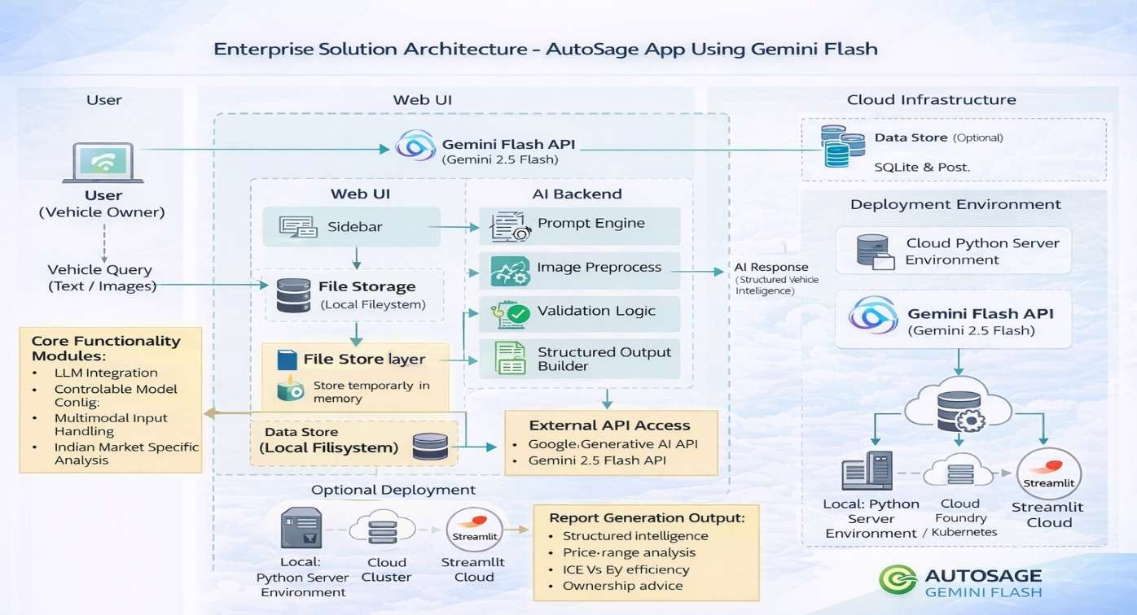
Example - Solution Architecture Diagram:

